
MANAV RACHNA UNIVERSITY, FARIDABAD
Department of Computer Science and Technology

Course: B.Tech (CST)
Subject: Programming for Problem Solving using Python(CSW208B) Session: 2020-21

LAB-1
- Writing a program to print a welcome message.
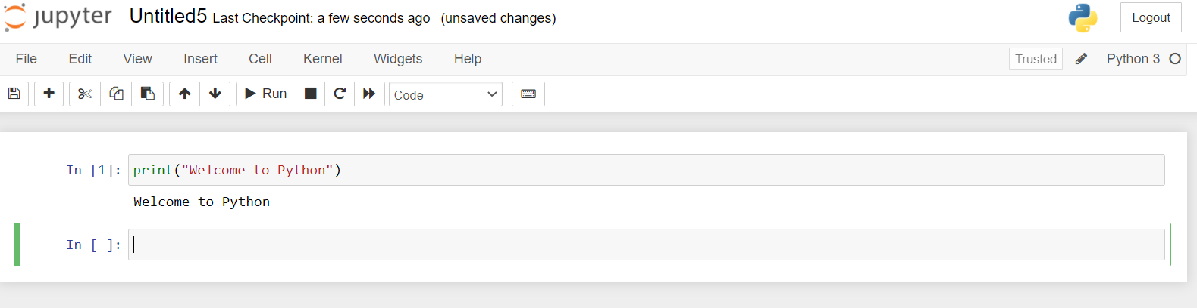
- Write a program to add two numbers.
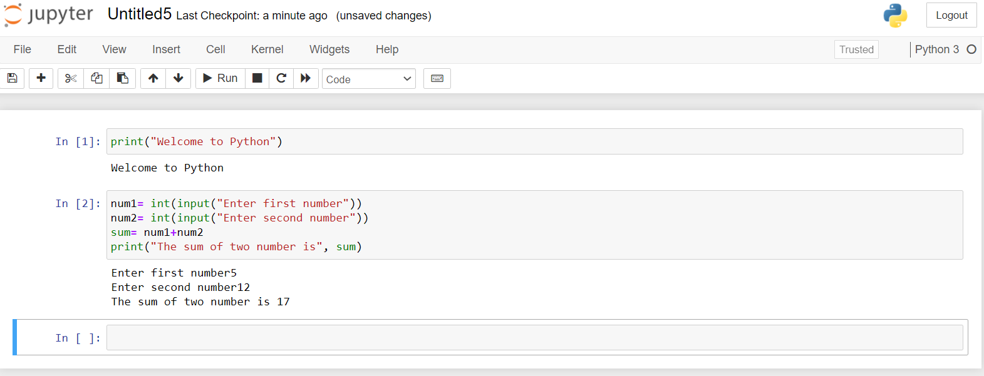
- Write a program to take first name, middle name and last name from the user. Greet the user.
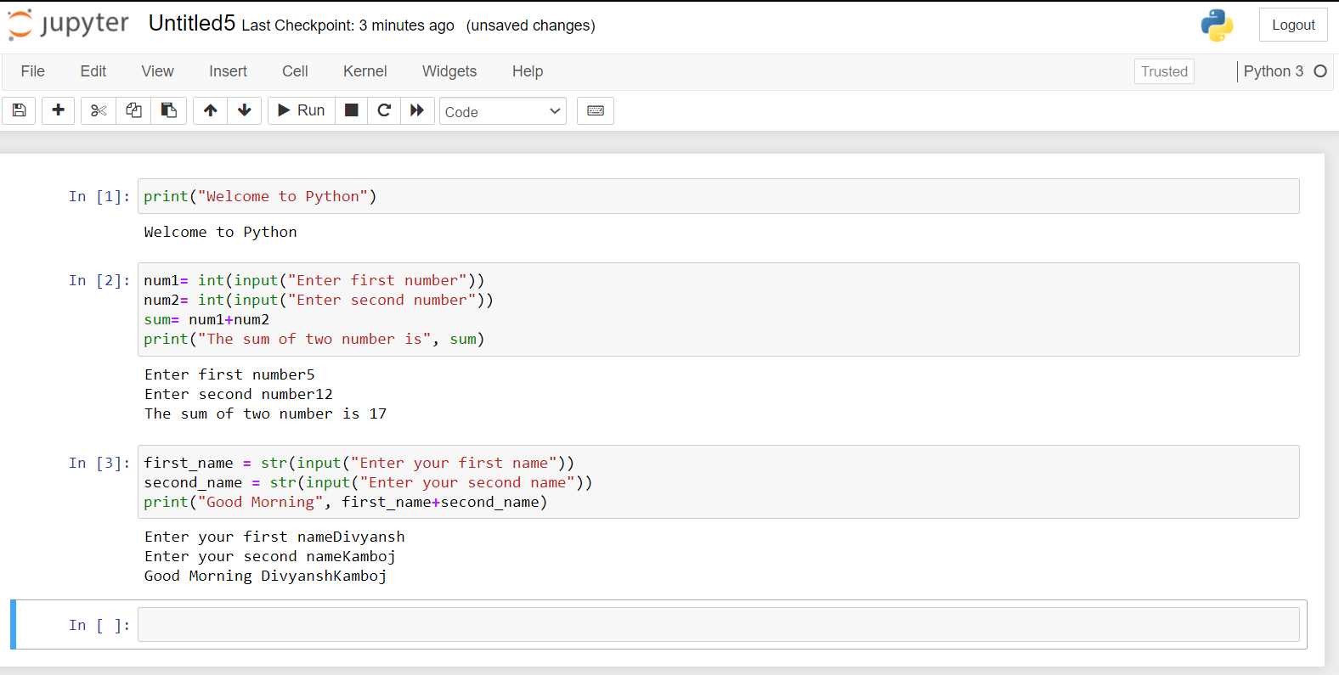

LAB-2
- Check whether a number is even or odd
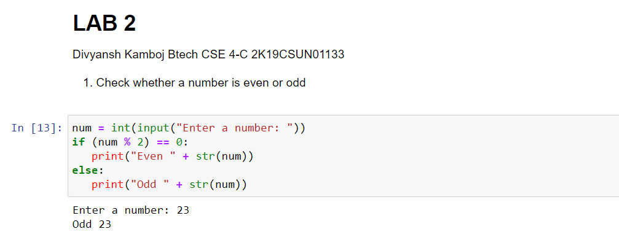
- Check whether an entered year is leap year or not.
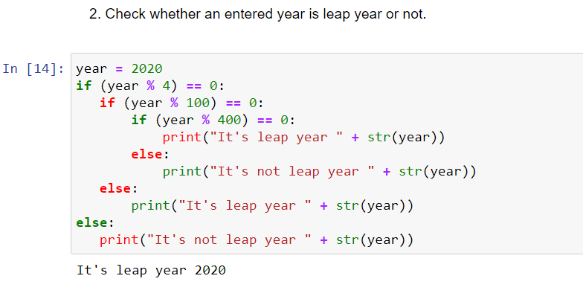
- Write a program to check whether a character is vowel or
consonants.
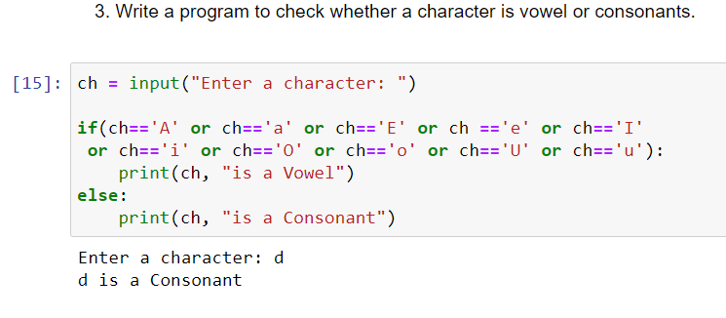
- Write a program to find the smallest of two numbers.
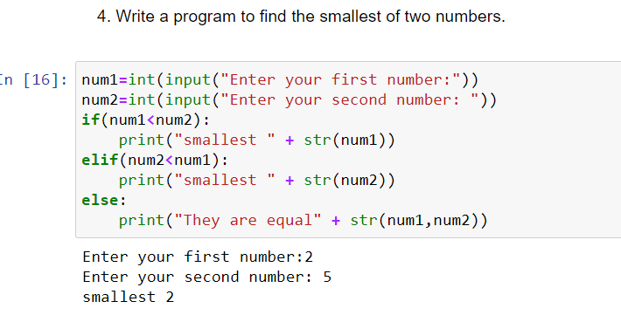
- Find the Factorial of a Number
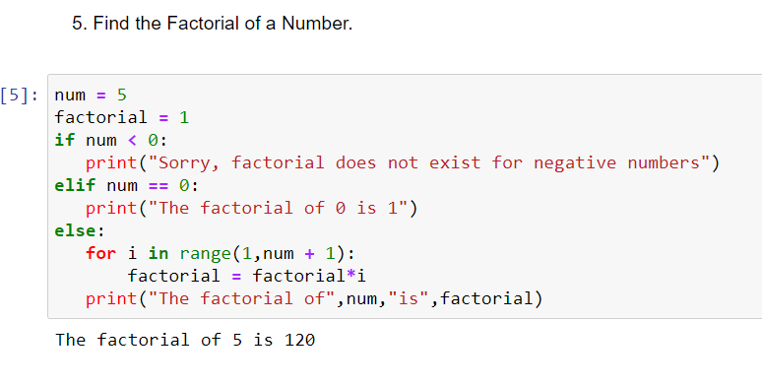
- Write a program to print this patterns
*
* *
* * *
* * * *
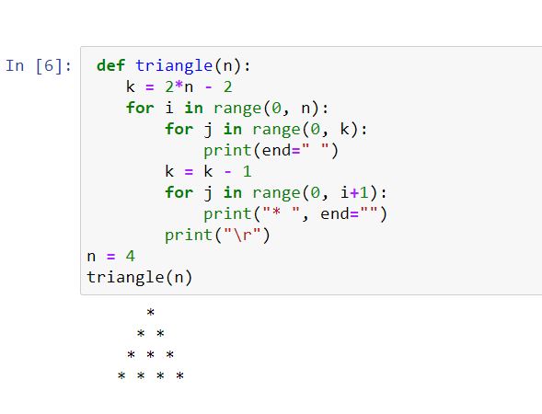
- Write a program to print this series
1 1 2 3 5 8 13
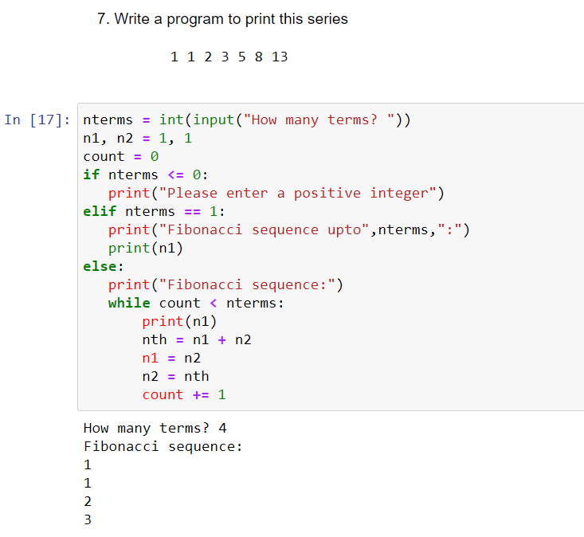
- Check whether a number is prime or not
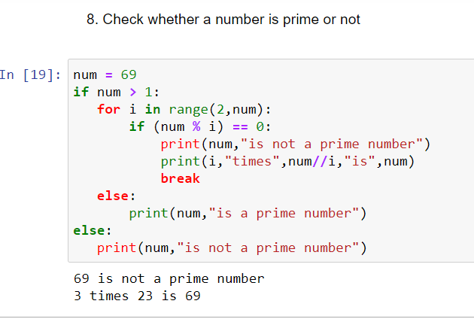
- Make a Simple Calculator.
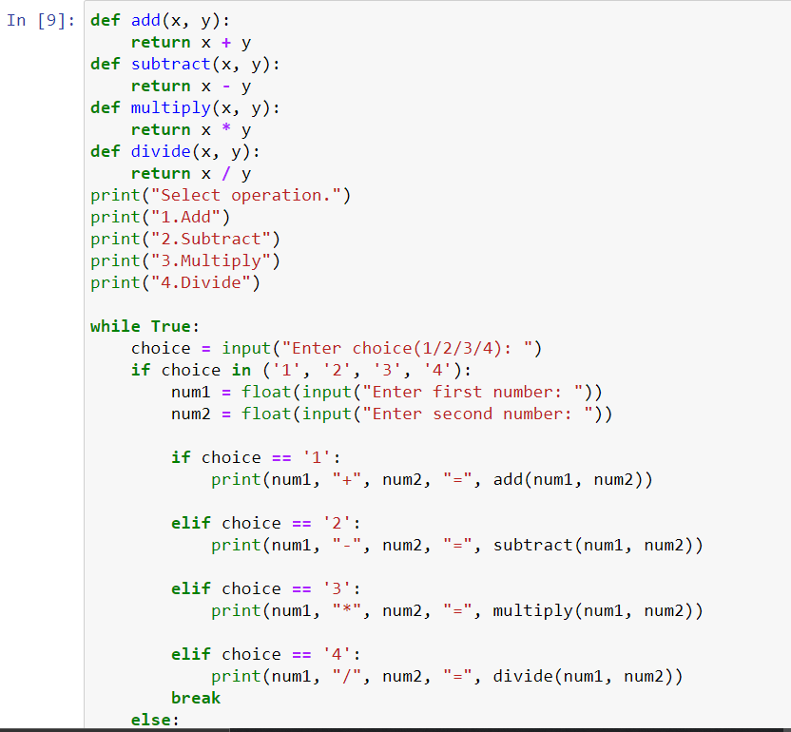
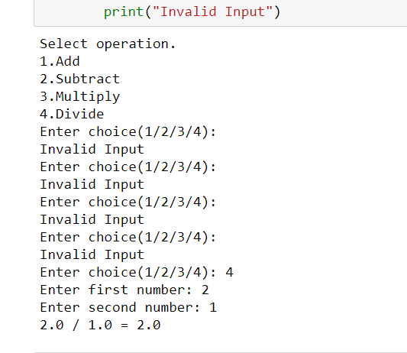

LAB-3
- WAP to demonstrate while loop with else statement.
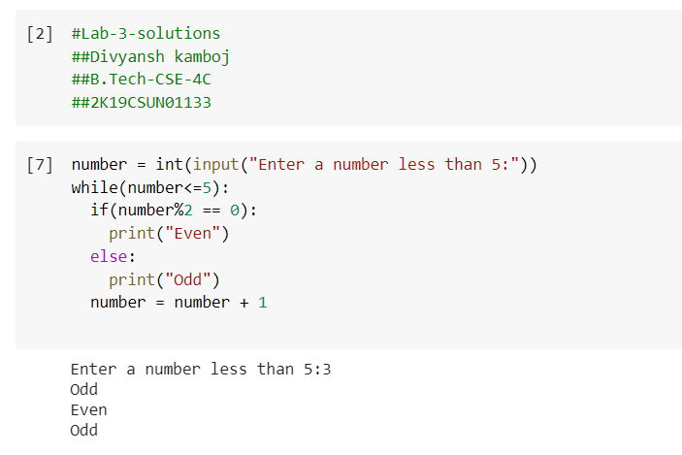
- Print 1st 5 even numbers (use break statement).
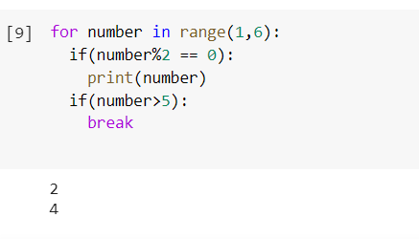
- Print 1st 4 even numbers (use continue statement).
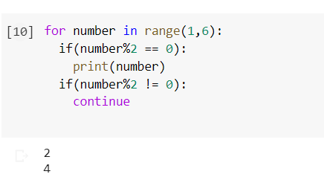
- WAP to demonstrate Pass statements.
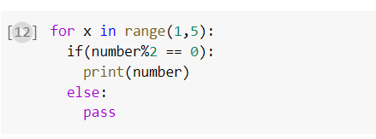
NO OUTPUT IN THIS CASE.
- Write a Python program to calculate the length of a string.
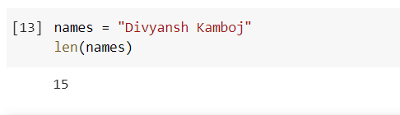
- Write a Python program to count the number of characters (character frequency) in a string
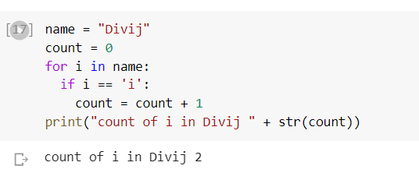

- Write a Python program to get a string made of the first 2 and the last 2 chars from a given a string. If the string length is less than 2, return instead of the empty string.
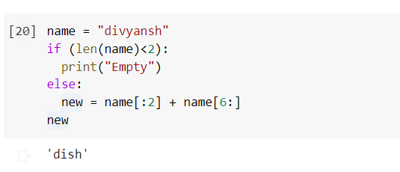
- Write a Python program to get a string from a given string where all occurrences of its first char have been changed to '$', except the first char itself
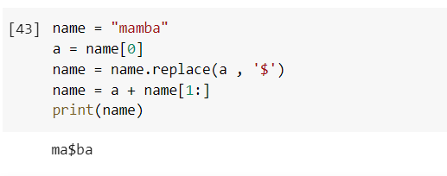
- Write a Python program to get a single string from two given strings, separated by a space and swap the first two characters of each string.
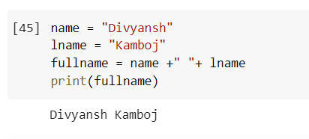
- Write a Python program to add 'ing' at the end of a given string (length should be at least 3). If the given string already ends with 'ing' then add 'ly' instead. If the string length of the given string is less than 3, leave it unchanged

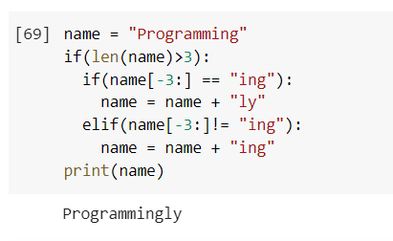
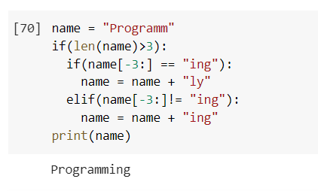
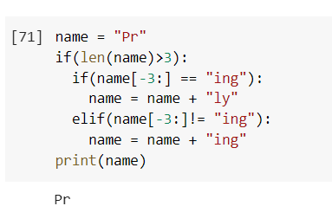

LAB-4-5
Tuple
1. Write a Python program to create a tuple. t1= ()
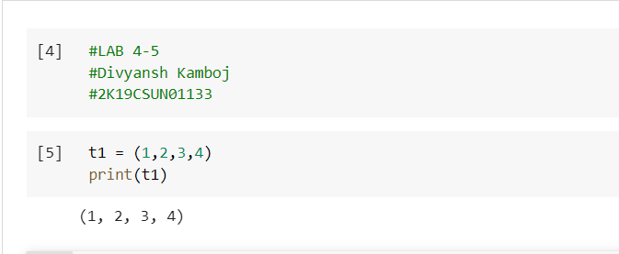
2. Write a Python program to create a tuple with different data types.
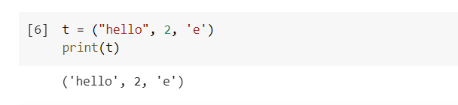
3. Write a Python program to create a tuple with numbers and print one item.
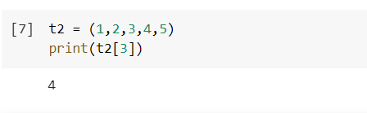
4. Write a Python program to unpack a tuple in several variables.
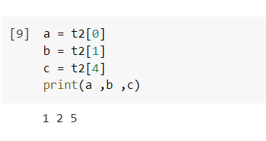
5. Write a Python program to add an item in a tuple.
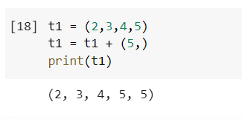
6. Write a Python program to convert a tuple to a string.
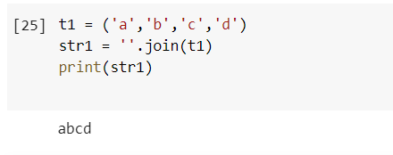
7. Write a Python program to get the 4th element and 4th element from last of a tuple
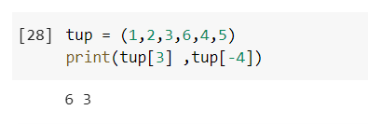
8. Write a Python program to create the colon of a tuple.
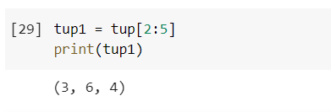
9. Write a Python program to find the repeated items of a tuple.
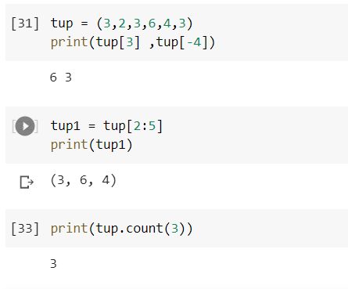
10. Write a Python program to check whether an element exists within a tuple.

11. Write a Python program to convert a list to a tuple.
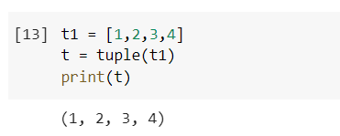
12. Write a Python program to remove an item from a tuple.
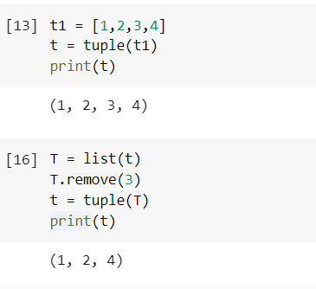
13. Write a Python program to slice a tuple
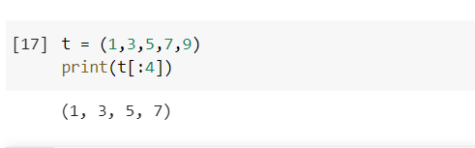
14. Write a Python program to find the index of an item of a tuple.
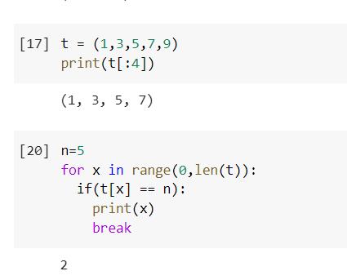
15. Write a Python program to find the length of a tuple.
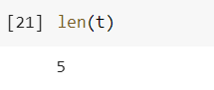
16. Write a Python program to reverse a tuple.
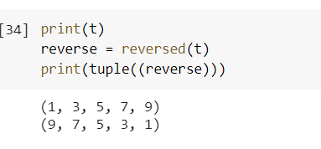

List
1. Write a Python program to sum all the items in a list.
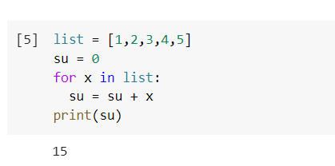
2. Write a Python program to multiplies all the items in a list.
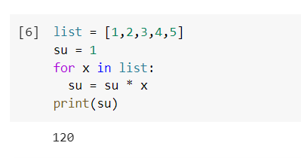
3. Write a Python program to get the largest number from a list
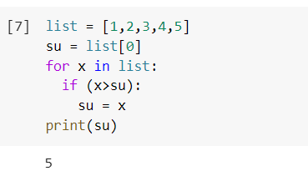
4. Write a Python program to get the smallest number from a list.
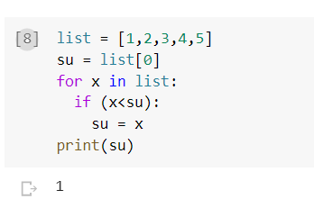
5. Write a Python program to count the number of strings where the string length is 2 or more and the first and last character are same from a given list of strings
Sample List : ['abc', 'xyz', 'aba', '1221']
Expected Result : 2
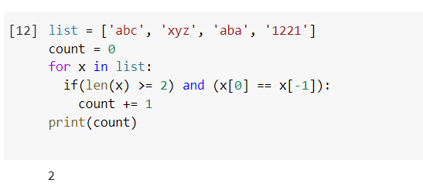

6. Write a Python program to get a list, sorted in increasing order by the last element in each tuple from a given list of non-empty tuples.
Sample List : [(2, 5), (1, 2), (4, 4), (2, 3), (2, 1)]
Expected Result : [(2, 1), (1, 2), (2, 3), (4, 4), (2, 5)]
7. Write a Python program to remove duplicates from a list.
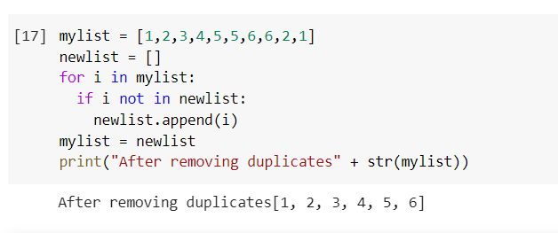
8. Write a Python program to check a list is empty or not.
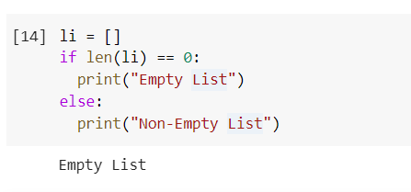
9. Write a Python program to clone or copy a list.
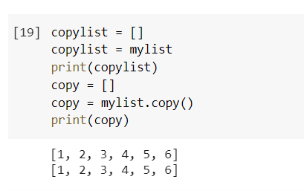
10. Write a Python program to find the list of words that are longer than n from a given list of words.
11. Write a Python function that takes two lists and returns True if they have at least one common member.
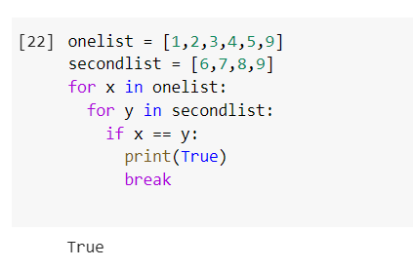

12. Write a Python program to print a specified list after removing the 0th, 4th and 5th elements.
Sample List : ['Red', 'Green', 'White', 'Black', 'Pink', 'Yellow']
Expected Output : ['Green', 'White', 'Black']
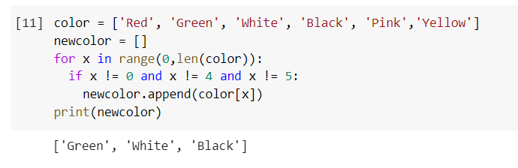

LAB-6
Dictionary
- Create an empty dictionary
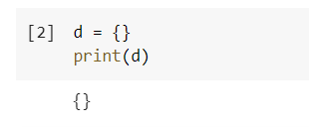
- Create the following dictionary
  - Key value
  - A 10
  - B 20
d={‘A’:10,’B’:20}
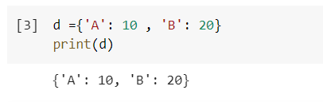
- Create a dictionary with different datatypes for keys
d1={‘A’:1,2:’two’,3.0:’Three’}
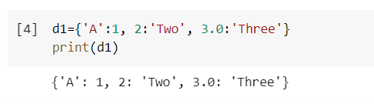
- Print all the items of a dictionary
- Delete an element of a dictionary
del(d[‘B’])
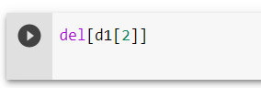
- Delete full dictionary
del(d)
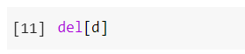
- Print a value for a key
print(d[‘A’])
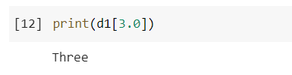
- To check if a key id present in a dictionary
‘A’ in d
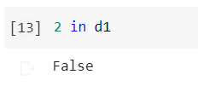
- Update a value of a key
d[‘A’]=50
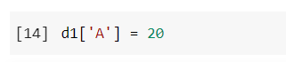
- Add a new key value pair
d[‘C’]=90
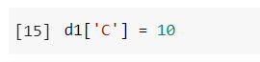
- Print dictionary for keys{1,10} and values as square of keys

{1:1,2:4,3:9,4:16,5:25…..10:100}
d={}
for I in range(1,11):
d[i]=i*i
print(d)
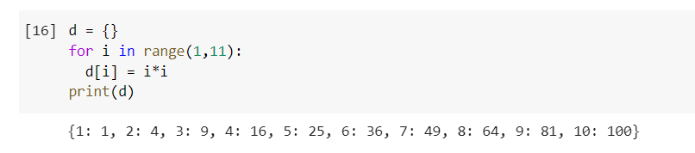
- Print nested dictionary
dict={1:{‘A’:10,’B’:20}}
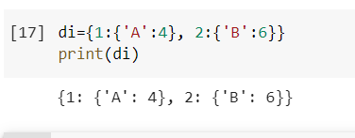
- Concatenate three dictionaries
Sample Dictionary :
dic1={1:10, 2:20}
dic2={3:30, 4:40}
dic3={5:50,6:60}
Expected Result : {1: 10, 2: 20, 3: 30, 4: 40, 5: 50, 6: 60}
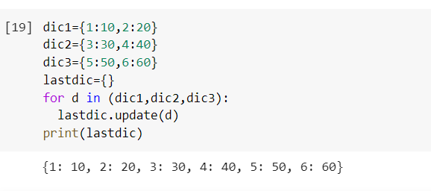
- Sum all the values of a dictionary
for I in d.keys():
sum=sum+d[i]
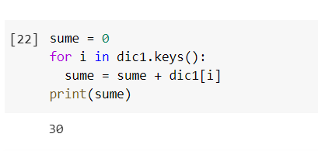
- Accessing an element of a nested dictionary
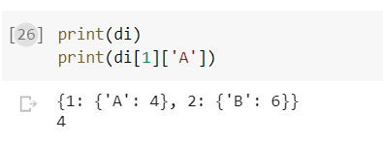

- Write a Python script to print a dictionary where the keys are numbers between 1 and 15 (both included) and the values are square of keys.
Sample Dictionary
{1: 1, 2: 4, 3: 9, 4: 16, 5: 25, 6: 36, 7: 49, 8: 64, 9: 81, 10: 100, 11: 121, 12: 144, 13: 169, 14: 196, 15: 225}
- Insert factorial of keys in values. And print dictionary

d={1:1,2:2,3:6,4:24,5:120….}
Sets
- Write a program to create a set
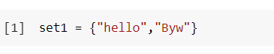
- Write a program to add an element to set
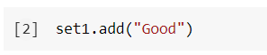
- Write a program to add multiple items using update function
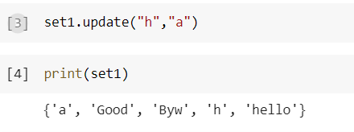
- Write a program to find length of a set
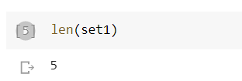
- Write a program to remove value from a set
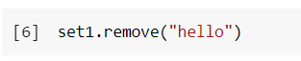
- Write a program to pop an element from a set
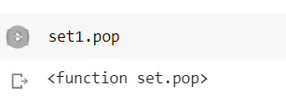
- Write a program to update a set
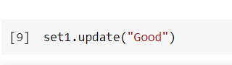
- Write a Python program to create an intersection of sets.
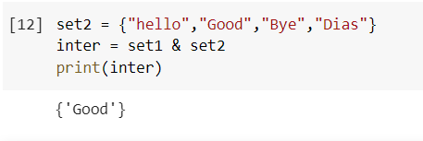
- Write a Python program to create a union of sets.
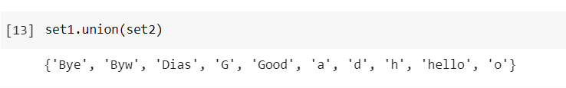
- Write a Python program to clear a set.
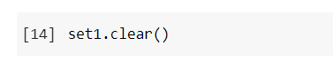
- Write a Python program to issubset and issuperset.
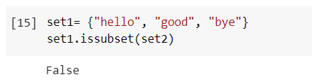
- Write a Python program to create set difference.
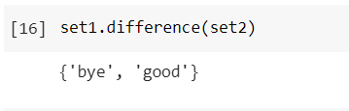

- Write a Python program to create a symmetric difference.
